Demo1:pupup for changing background color

# 大綱

Chrome 提供的擴充功能(Extensions)可以讓程式人員利用 HTML, CSS, 和 JavaScript，來擴充Chrome功能。

這裡的範例，用來改變目前網頁（active page or active tab）的背景顏色。

利用UI element([**browser action**](https://developer.chrome.com/extensions/browserAction))，可以在Chrome的Omnibox加入按鈕。如下圖：

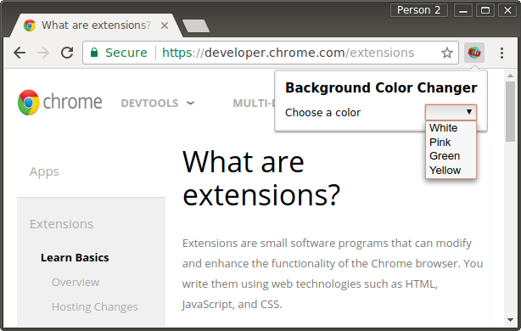

# Something to Declare

第一件事，就是建立manifest檔案manifest.json。利用JSON規格，指定擴充功能的名稱、描述、版本、permissions。

其中，permissions用來限定擴充功能的執行（參考 [**Manifest File Format documentation**](https://developer.chrome.com/extensions/manifest)）。

manifest.json([remote](https://developer.chrome.com/extensions/examples/tutorials/getstarted/manifest.json))

在這個例子中，宣告了一個 [browser action](https://developer.chrome.com/extensions/browserAction)，和 [activeTab permission](https://developer.chrome.com/extensions/activeTab) 允許檢查current tab 的URL和storage ，並用來記住使用者對這個網頁背景顏色的選擇。

{

"manifest_version": 2,

"name": "Getting started example",

"description": "This extension allows the user to change the background color of the current page.",

"version": "1.0",

"browser_action": {

"default_icon": "icon.png",

"default_popup": "popup.html"

},

"permissions": [

"activeTab",

"storage"

]

}

|  |
| --- |
| "activeTab" permission, 對目前的active tab開放存取權。  然後經由chrome.tabs API可以得到網頁的URL  chrome.tabs.query({active: **true**, currentWindow: **true**}, **function**(tabs) {  **var** currentURL **=** tabs[0].url;  // 在這裡可以利用currentURL (這裡是callback function).  });  // 這裡不能用currentURL； 因為函數query（）中的第2個參數已經指定是 asynchronous |

## Resources

icon.png :

popup.html.

popup.js

remote( [**icon.png**](https://developer.chrome.com/extensions/examples/tutorials/getstarted/icon.png), [**manifest.json**](https://developer.chrome.com/extensions/examples/tutorials/getstarted/manifest.json), [**popup.html**](https://developer.chrome.com/extensions/examples/tutorials/getstarted/popup.html),[**popup.js**](https://developer.chrome.com/extensions/examples/tutorials/getstarted/popup.js).)

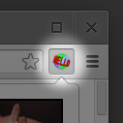icon.png

##### 【popup.html】

<!doctype html**>**

<!--

This page is shown when the extension button is clicked, because the

"browser_action" field in manifest.json contains the "default_popup" key with

value "popup.html".

-->

**<html>**

**<head>**

**<title>**Getting Started Extension's Popup**</title>**

**<style** type**=**"text/css"**>**

body {

margin: 10px;

white**-**space: nowrap;

}

h1 {

font**-**size: 15px;

}

#container {

align**-**items: center;

display: flex;

justify**-**content: space**-**between;

}

**</style>**

<!--

- JavaScript and HTML must be in separate files: see our Content Security

- Policy documentation[1] for details and explanation.

-

- [1]: https://developer.chrome.com/extensions/contentSecurityPolicy

-->

**<script** src**=**"popup.js"**></script>**

**</head>**

**<body>**

**<h1>**Background Color Changer**</h1>**

**<div** id**=**"container"**>**

**<span>**Choose a color**</span>**

**<select** id**=**"dropdown"**>**

**<option** selected disabled hidden value**=**''**></option>**

**<option** value**=**"white"**>**White**</option>**

**<option** value**=**"pink"**>**Pink**</option>**

**<option** value**=**"green"**>**Green**</option>**

**<option** value**=**"yellow"**>**Yellow**</option>**

**</select>**

**</div>**

**</body>**

**</html>**

##### 【popup.js】

// Copyright (c) 2014 The Chromium Authors. All rights reserved.

// Use of this source code is governed by a BSD-style license that can be

// found in the LICENSE file.

/**

* Get the current URL.

*

* @param {function(string)} callback called when the URL of the current tab

* is found.

*/

**function** getCurrentTabUrl(callback) {

// Query filter to be passed to chrome.tabs.query - see

// https://developer.chrome.com/extensions/tabs#method-query

**var** queryInfo **=** {

active: **true**,

currentWindow: **true**

};

chrome.tabs.query(queryInfo, (tabs) **=>** {

// chrome.tabs.query invokes the callback with a list of tabs that match the

// query. When the popup is opened, there is certainly a window and at least

// one tab, so we can safely assume that |tabs| is a non-empty array.

// A window can only have one active tab at a time, so the array consists of

// exactly one tab.

**var** tab **=** tabs[0];

// A tab is a plain object that provides information about the tab.

// See https://developer.chrome.com/extensions/tabs#type-Tab

**var** url **=** tab.url;

// tab.url is only available if the "activeTab" permission is declared.

// If you want to see the URL of other tabs (e.g. after removing active:true

// from |queryInfo|), then the "tabs" permission is required to see their

// "url" properties.

console.assert(**typeof** url **==** 'string', 'tab.url should be a string');

callback(url);

});

// Most methods of the Chrome extension APIs are asynchronous. This means that

// you CANNOT do something like this:

//

// var url;

// chrome.tabs.query(queryInfo, (tabs) => {

// url = tabs[0].url;

// });

// alert(url); // Shows "undefined", because chrome.tabs.query is async.

}

/**

* Change the background color of the current page.

*

* @param {string} color The new background color.

*/

**function** changeBackgroundColor(color) {

**var** script **=** 'document.body.style.backgroundColor="' **+** color **+** '";';

// See https://developer.chrome.com/extensions/tabs#method-executeScript.

// chrome.tabs.executeScript allows us to programmatically inject JavaScript

// into a page. Since we omit the optional first argument "tabId", the script

// is inserted into the active tab of the current window, which serves as the

// default.

chrome.tabs.executeScript({

code: script

});

}

/**

* Gets the saved background color for url.

*

* @param {string} url URL whose background color is to be retrieved.

* @param {function(string)} callback called with the saved background color for

* the given url on success, or a falsy value if no color is retrieved.

*/

**function** getSavedBackgroundColor(url, callback) {

// See https://developer.chrome.com/apps/storage#type-StorageArea. We check

// for chrome.runtime.lastError to ensure correctness even when the API call

// fails.

chrome.storage.sync.get(url, (items) **=>** {

callback(chrome.runtime.lastError ? null : items[url]);

});

}

/**

* Sets the given background color for url.

*

* @param {string} url URL for which background color is to be saved.

* @param {string} color The background color to be saved.

*/

**function** saveBackgroundColor(url, color) {

**var** items **=** {}; //空物件

items[url] **=** color; //無法使用 一般物件新增欄位的方式，例如items.url=color 因為url 是字串。

// [參考](https://developer.chrome.com/apps/storage#type-StorageArea) We omit the

// optional callback since we don't need to perform any action once the

// background color is saved.

chrome.storage.sync.set(items);

}

// This extension loads the saved background color for the current tab if one

// exists. The user can select a new background color from the dropdown for the

// current page, and it will be saved as part of the extension's isolated

// storage. The chrome.storage API is used for this purpose. This is different

// from the window.localStorage API, which is synchronous and stores data bound

// to a document's origin. Also, using chrome.storage.sync instead of

// chrome.storage.local allows the extension data to be synced across multiple

// user devices.

document.addEventListener('DOMContentLoaded', () **=>** {

getCurrentTabUrl((url) **=>** {

**var** dropdown **=** document.getElementById('dropdown');

// Load the saved background color for this page and modify the dropdown

// value, if needed.

getSavedBackgroundColor(url, (savedColor) **=>** {

**if** (savedColor) {

changeBackgroundColor(savedColor);

dropdown.value **=** savedColor;

}

});

// Ensure the background color is changed and saved when the dropdown

// selection changes.

dropdown.addEventListener('change', () **=>** {

changeBackgroundColor(dropdown.value);

saveBackgroundColor(url, dropdown.value);

});

});

});

## Load the extension

chrome://extensions

## Code 註解

按鈕相關的tooltip 可以在manifest 檔案中，browser_action指定，例如：

{

...

"browser_action": {

"default_icon": "icon.png",

"default_popup": "popup.html",

"default_title": "Click here!"

},

...

}

如果有更動，必須重載，才能正確顯示(課堂操作). 或是直接按F5（或CTRL─R）。 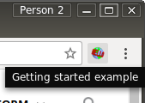 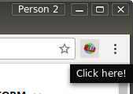

## 其他參考

[**Chrome Extension Overview**](https://developer.chrome.com/extensions/overview)

[**debugging tutorial**](https://developer.chrome.com/extensions/tut_debugging)

[**chrome.* APIs documentation**](https://developer.chrome.com/extensions/api_index) : 程式中相關browser actions的APIs。

[**developer's guide**](https://developer.chrome.com/extensions/devguide) 。